SUBJECT: **Computer Science**

CLASS: XII SEC: A4

YEAR: 2016-17

NAME: R. Pravin

***CONTENTS***

1. Problem definition
2. Problem analysis

* Student details
* Attendance register
* time table
* stock details
* requirements
* graphics

1. Hardware requirements
2. Software requirements
3. Future enhancements
4. Source code
5. Output
6. Bibliography

***Problem definition:***

* + - To develop an user interactive, simple software that can store, enhance and utilize very important information about the students, like their phone no. attendance, etc. Also store the basic requirements of a physic laboratory and store the stock details of the lab, making the lab operations electronic, permanent and safe.
* To take attendance of the students present and to have a summary of the class strength and save it files for future references if required.
* To make the lab proceeding secured with password and centralizes the lab activities to make the processes paper free.
* To get the list of apparatus required to be bought at one click and reduce the usage of paper for making list (eco-friendly way)
* Reduce the time for process and filling up of attendance list.

***Problem analysis:***

***The Options in the main menu:***

The main menu consists of the following options:

1. Student
2. Attendance
3. Time table
4. Stock
5. Requirements

***Student:***

The student tab contains the options

1. Add a student’s details that will be stored in the student details binary file.
2. To edit the student details and the various changes can be implemented.
3. View option is to show the details of the students present in the binary file to the user.
4. Delete option is to delete a particular students detail from the storage file.

***Attendance:***

The attendance tab contains the options

1. Take option is used to enter the attendance of the required class by providing the date and the class, sec.

The students list will be displayed as per roll no. order and the attendance entry can be made.

1. The view option can be used to check the attendance list of a particular class on a particular day by entering the date and class.
2. The report option displays a brief summary of the attendance of a particular class on a particular day.

***Timetable:***

The timetable tab contains the options to

1. View option is to display the time table of a particular day or the future activities that is to be held.

The details of the time table will be stored already as a binary file and can also be edited by using the edit option in the timetable tab on the main menu.

1. Edit option is to change or edit the time table list if and when required.

***Stock:***

The stock tab contains the options

1. The input option is to add a new apparatus to the list, which is present in a binary file “stock details”, when it is added to the lab.
2. Edit to make changes to the already exiting apparatus

i.e., to change the value, no. present, etc.

1. View option is to view the list of apparatus present in the binary file containing the stock details.
2. Delete option is to remove a damaged apparatus from the list or from the data file.

***Requirements:***

The requirements tab contains the options

1. Input option is to get the requirement details of the apparatus to be bought for the lab and store the details in a binary file requirement details.
2. Edit option is to edit the details of the apparatus in the list.
3. View option is to display the list of apparatus required to be bought.
4. Delete option is to delete the apparatus that is bought and which makes the changes in the file containing the list.

***GRAPHICS:***

Graphics is used to insert text boxes and to highlight the text in different colors. Also to insert the mouse pointer to navigate between the options and menus in the main menu.

It is also used for making a eye catching title animation in the beginning.

***HARDWARE REQUIREMENTS:-***

The basic requirements are:

1. Mouse
2. Key board
3. Sufficient storage capacity to store the files for details of students and apparatus(1mb space or above)
4. A basic functioning computer with minimum RAM

(Above 512mb)

***SOFTWARE REQUIREMENTS:***

The basic requirements are:

1. C++ compiler.
2. DOS box.

***FUTURE ENHANCEMENTS:***

1. To check the correctness of the email address entered.
2. To create a link between requirements and stock so that when we buy an apparatus immediately it be added to the stock details.
3. To check the date and automatically show the day.
4. To improve the graphics.
5. To make printing of the requirements list possible so that it will be easy to take it to the stores to buy.

***BIBILIOGRAPHY:***

The text books referred are:

1. NCERT text book
2. Text book on c++

By Sumita Arora

Websites referred:

<http://stackoverflow.com/>

<https://en.wikipedia.org/wiki/C%2B%2B>

<https://www.tutorialspoint.com/cplusplus/>

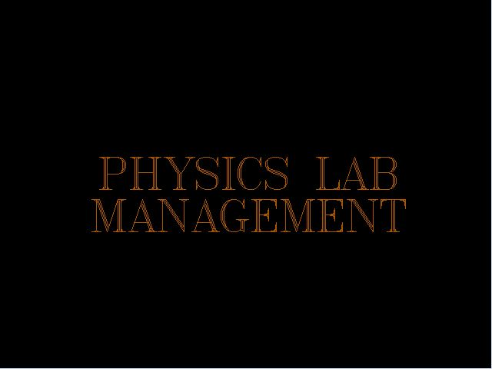

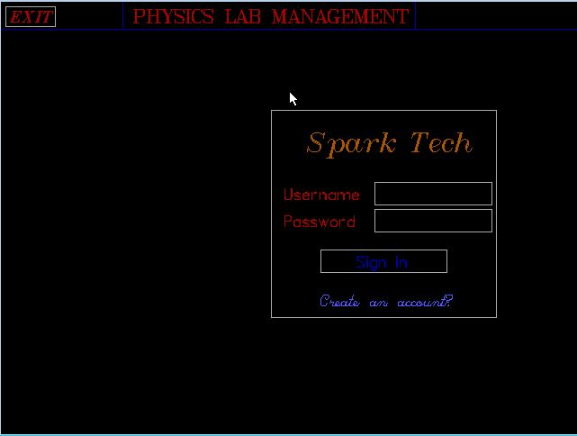

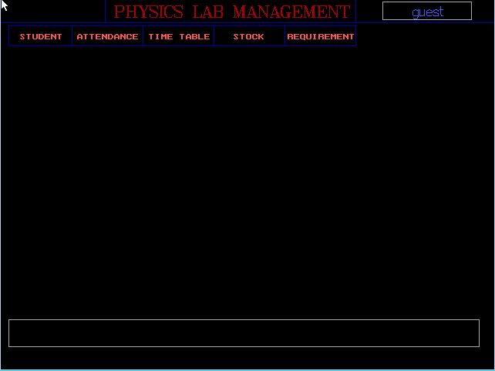

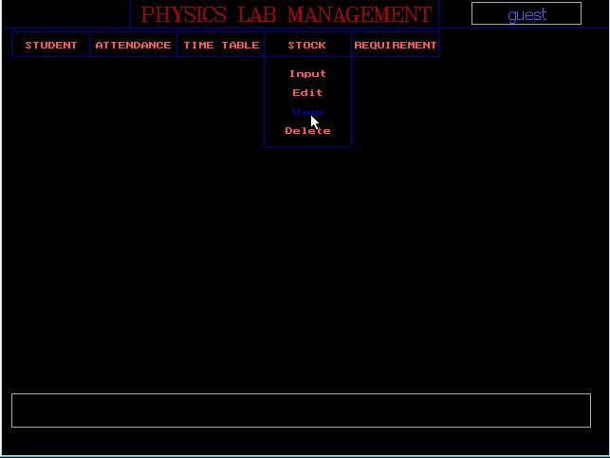

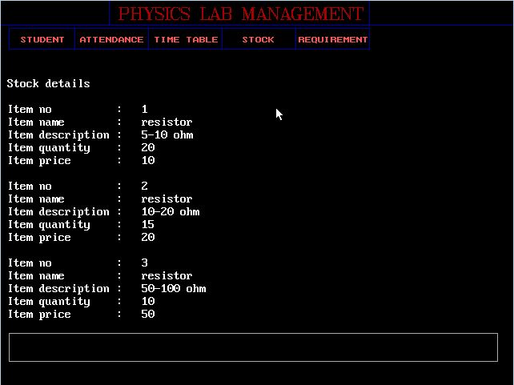

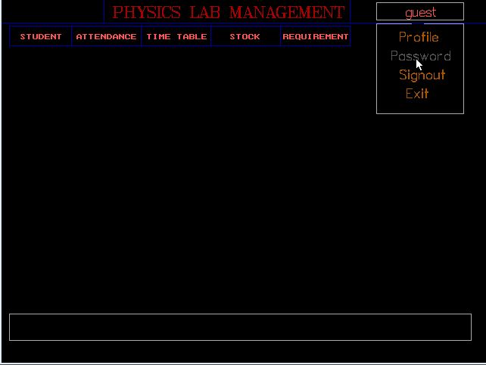

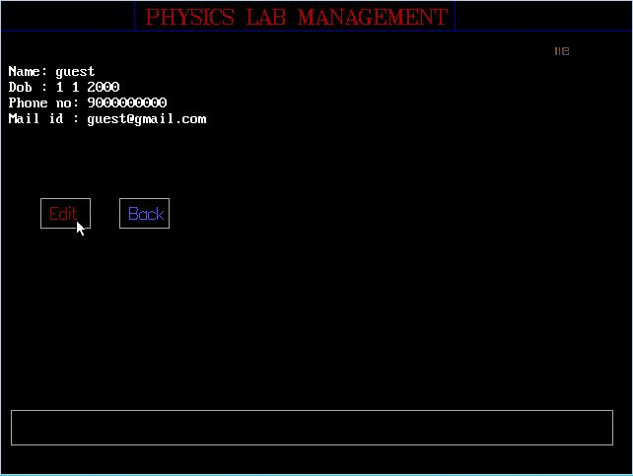

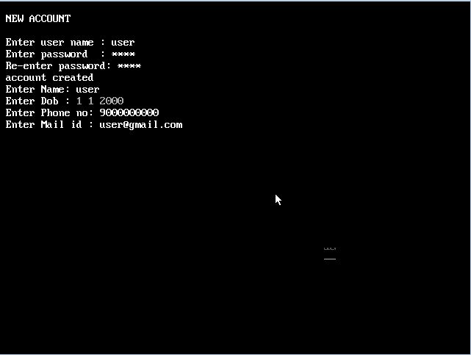

GitHub Repository Link: <https://github.com/pravin014/Physic-Lab-Management-System-using-TuboC.git>